Google Play

Generalidades sobre Google Play

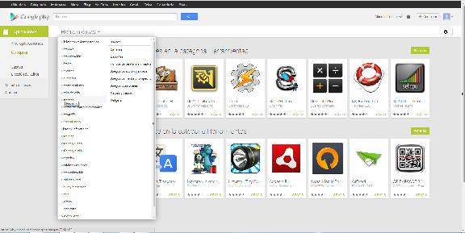

REFERENCIAS

<http://www.androidauthority.com/new-google-play-store-review-189438/>

<http://news.google.es/>

<https://play.google.com/about/play-terms.html>

<http://www.google.com/intl/es-419/policies/privacy/>